

ASSET VERIFICATION AND RECORDING TOOL KIT


Plot 31, Bukoto Street
P.O Box 7657, Kampala, Uganda
+256 (0) 39 2000216/0772525235
email: cpa@cpa.ug

www.cpa.com

August to September 2026

VERIFICATION DETAILS

NAME OF THE REGION: | WESTERN
SUB-REGION: | TOORO
Name of Local Government | BUNDIBUGYO
VERIFIER PARTICULARS
Full name | ZALWANGO MARIA, NASSEJJE NADIA, NABBOSA SUMAYA
Contact/ email and Telephone | 0751977570/ 0754884004/ 0708098456
Supervisor/ Sub team leader
Name | DEPAUL MBONIGABA
Contact | 0788483159
Date of submission

HEALTH CENTRES
INFORMANT INTERVIEW/DISCUSSION GUIDE (INCHARGE OR RESPONSIBLE PERSON)

Name of Health Centre: BUPOMBOLI HEALTH CENTER III

1a | Does the Facility have a record of all assets provided under UgIFT.  (Obtain a record and verify if it has the costs and numbers supplied | Yes, but it has no costs
1b | If Not ask how many were supplied and when.

2 | How does this facility Maintain (repair/service/replace) the assets provided under Ugift

The facility informs the regional hospital incase of any breakdown of a machine then it sends a specialist.

3 | Does the facility take regular record about functionality/ or breakdown of the assets provided? | Yes

4 | How has the UgIFT support helped in service delivery in the area, any issues, challenges and any recommendations for better program implementation.

Support Ugift has provided a comfortable environment to the community.

Challenges
Some equipments lack specialists to be worked up on like microscope. They don’t have a laboratory. Stock outs of tabs due to a lot of patients.

Recommendations

More buildings are needed for example a laboratory. Need of training for the staff members and more specialists are needed.

PROCEED TO VERIFICATION AFTER THIS DISCUSSION

Health centre checklist

NAME OF LG: KABAROLE DISTRICT NAME OF HEALTH FACILITY: BUPOMBOLI HC III

Equipment/ Item | Department | Asset Number | Item  Description | Life in Months | Tag Number ( engrave no.) | Date Of Purchase | Date Placed In Service | Recoverable cost | Cost | Acc Dep Cost | Net Book Value | Ytd Deprn | Equipment status | Remarks
B.P. Machine, Digital
B.P. Machine (Aneroid wall mounted) | Health
Autoclave 20 Liters.,Duo Operated | Health |  | White in colour |  |  |  |  |  |  |  |  |  | Functional | 1 still in store
Bowl, Kick | Health
Bowl Stand | Health |  | Silver in color and metallic |  |  |  |  |  |  |  |  |  | Good condition | Still in store
Counting chamber Neubauer- Improved
Cupboard Steel, Lockable | Health |  | Steel and Grey in colour |  |  |  |  |  |  |  |  |  | Good condition | 3 in use and verified
Drip Stand | Health |  | Have wheels and a metallic stand silver in colour |  |  |  |  |  |  |  |  |  | Good condition | 7are still in use.
ESR Stand
Examination Couch | Health |  | Black mattresses with metallic stand |  |  |  |  |  |  |  |  |  | Good condition | Received 1 and its not in use
Examination light,LED
Glucometer
Haemoglobin Meter, Digital
Height Meter | Health |  | White in colour |  |  |  |  |  |  |  |  |  | Good condition | 1 is in use
Instrument Trolley
Microscope Binocular | Health |  | Boxed |  |  |  |  |  |  |  |  |  | Good condition | Its stored well, not being used yet
Otoscope | Health |  | It was boxed |  |  |  |  |  |  |  |  |  | Boxed, in good condition | Still in store
Patient Screen
Patient Trolley | Health |  | Blue in colour |  |  |  |  |  |  |  |  |  | Functional | 3 They are in use but not enough
Refrigerator, Basic | Health |  | Boxed |  |  |  |  |  |  |  |  |  | Boxed | 1 Still in store
Stethoscope | Health |  |  |  |  |  |  |  |  |  |  |  | Good condition | 8 are still in store
Stop Watch | Health |  | Black in colour |  |  |  |  |  |  |  |  |  | Good condition | 3 still in store
Stretcher | Health |  | Blue with wheels |  |  |  |  |  |  |  |  |  | Good condition | 1 not in use
Stove, Gas | Health |  | Orange in colour with its plate |  |  |  |  |  |  |  |  |  | Good condition | 1 in use.
Weighing Scale with Height Meter, Adult
Weighing Scale, Infant | Health |  | Boxed |  |  |  |  |  |  |  |  |  | Good condition | 2 Still in store
Weighing Scale, Toddler
Wheel Chair | Health |  | Black and it has no wheels |  |  |  |  |  |  |  |  |  | Faulty | Not used
Audio Visual Equipment
Medical Waste Bin
Wall Clock | Health |  | Round shaped |  |  |  |  |  |  |  |  |  | Good condition | 2 n use and one still
Diagnostic Equipment Set for MCH
Diagnostic Equipment Set for OPD |  |  |  |  |  |  |  |  |  |  |  |  |  | 2 still
Glassware Set, Laboratory, Basic | Health |  | Silver in colour |  |  |  |  |  |  |  |  |  | Good condition | still in store
Hollow Ware Set, Treatment | Health |  | Silver metallic |  |  |  |  |  |  |  |  |  | Good condition | In use
Instrument Set, Dressing | Health |  | Boxed |  |  |  |  |  |  |  |  |  | Good condition | Not in use, still in store
Instrument Set, Basic ENT
Instrument Set, Suture | Health |  | Silver |  |  |  |  |  |  |  |  |  | Good condition | 1 In use
Pulse Oximeter, Hand held | Health |  |  |  |  |  |  |  |  |  |  |  |  | 1 Not received
Bed, Adult Patient with Mattress | Health |  | Black mattresses and silver metallic stands |  |  |  |  |  |  |  |  |  | Good condition | 13 are in use
Bed, Pediatric Patient, With Mattress | Health |  | Pink in colour |  |  |  |  |  |  |  |  |  | Good condition | They are in use.
Bedside Locker |  |  |  |  |  |  |  |  |  |  |  |  |  | Not received
Cupboard, Instrument | Health |  | Grey in colour |  |  |  |  |  |  |  |  |  | Good condition | 1 Not in use
Delivery Bed, Hydraulic Manual | Health |  | Pink in colour |  |  |  |  |  |  |  |  |  | Good condition | Its in use, one was delivered Nyaika.
Oxygen Therapy Apparatus, Mininum 45L cylinder | Health |  | Boxed |  |  |  |  |  |  |  |  |  | Good condition | 2 Not in use
Resuscitator Manual, Infant, with all Mask sizes
Resuscitator Manual, Adult, with all mask sizes
Suction Apparatus, (Electric)
Nebulizer, Ultrasonic | Health |  | Boxed |  |  |  |  |  |  |  |  |  | Good condition | 2 Not in use.  .
Oxygen Concentrator, Duo Flow | Health |  | Boxed |  |  |  |  |  |  |  |  |  | Good condition | 4 Not in use still in store.
Bench | OPD |  |  |  |  |  |  |  |  |  |  |  |  | Not yet received
Disinfection Buckets
Baby Cot | Health |  | black mattresses and silver stand |  |  |  |  |  |  |  |  |  | Good condition | 4 are in use.
Diagnostic Equipment Set for Ward
Hollow Ware Set, Ward | Health |  | Grey in colour |  |  |  |  |  |  |  |  |  | Good condition | 1 still in store
Instrument Set, Delivery
Instrument Set, Stitch Removing
MVA Kit | Health |  | Boxed |  |  |  |  |  |  |  |  |  | Good condition | 3 still in store
Stool, Laboratory | Health |  | Blue in colour |  |  |  |  |  |  |  |  |  | Good condition | 1 still in store
Penguin Sucker
Fetoscope, Dopplar | Health |  | Boxed |  |  |  |  |  |  |  |  |  | Good condition | 2 still in store
Bubble CPAP
Centrifuge (Electric) | Health |  | Boxed |  |  |  |  |  |  |  |  |  | Good condition | 1 still in store
Kangaroo Mother Care Chair
Radiant Infant Warmer
Haemoglobin Meter, Sahli
Delivery Bed
Examination light | Health |  | Black in colour |  |  |  |  |  |  |  |  |  | Good condition | 2 Not in use.
Instrument set, ENT Basic for HCIII
Bag Valve mask (Ambu Bag), Neonatal
Incubator
Office Chair | Health |  | Brown in colour with wheels |  |  |  |  |  |  |  |  |  | Good condition | 3 are in use.
Desk
Filing Cabinet | Health |  | Grey in colour steel |  |  |  |  |  |  |  |  |  | Good condition | 4 are in use.
Non Residential Buildings | Health |  | Painted orange and white |  |  |  |  |  |  |  |  |  | Good condition | Its not enough. More buildings are needed.
Residential Buildings

OPD Peadriatic bed
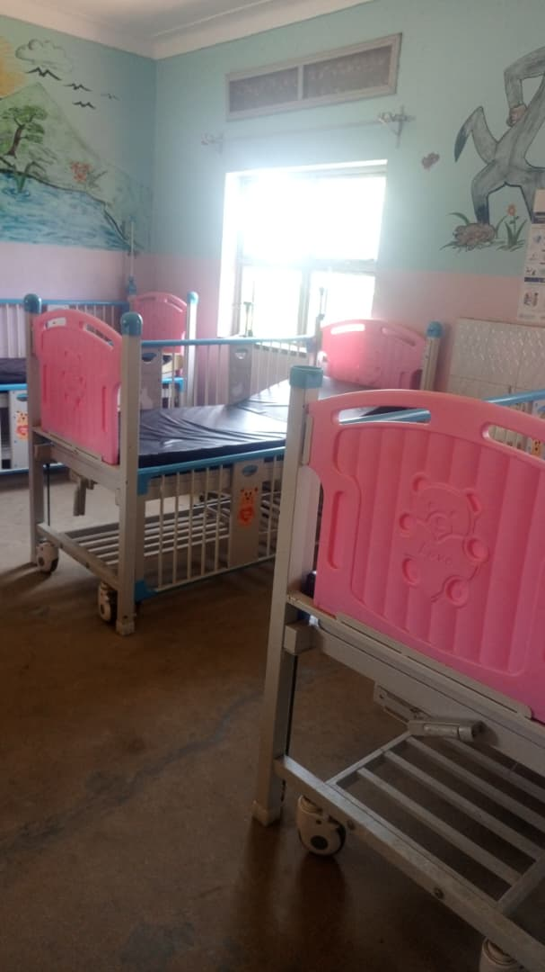
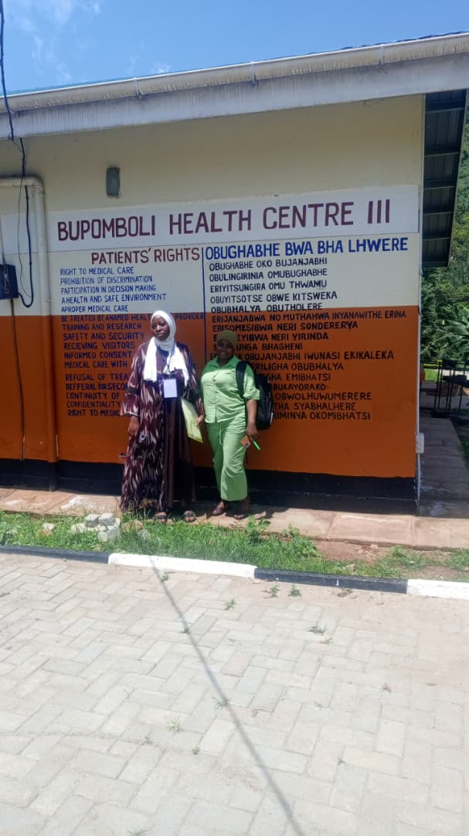

Power house power house
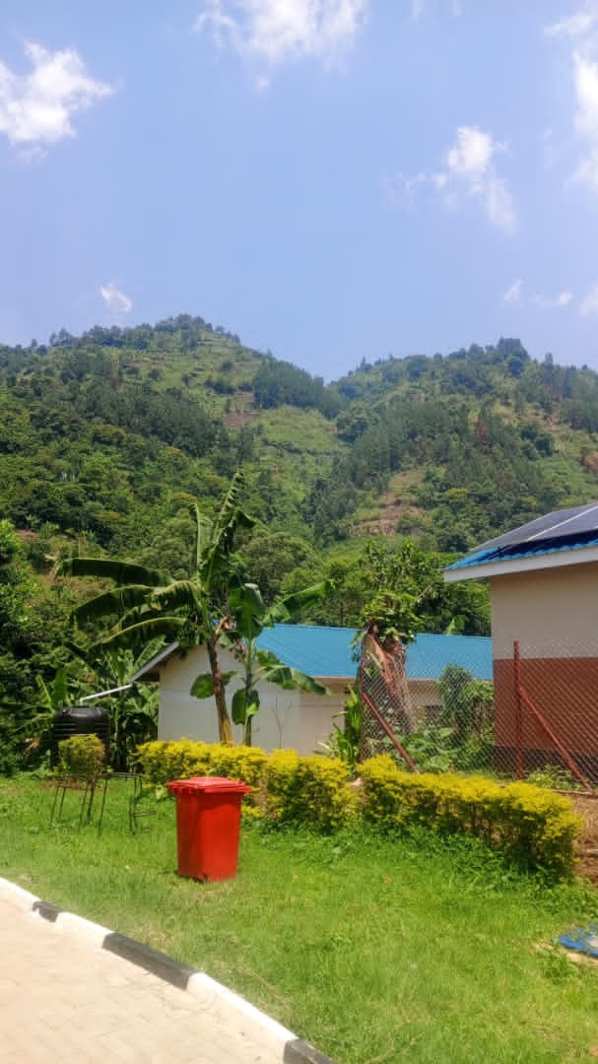
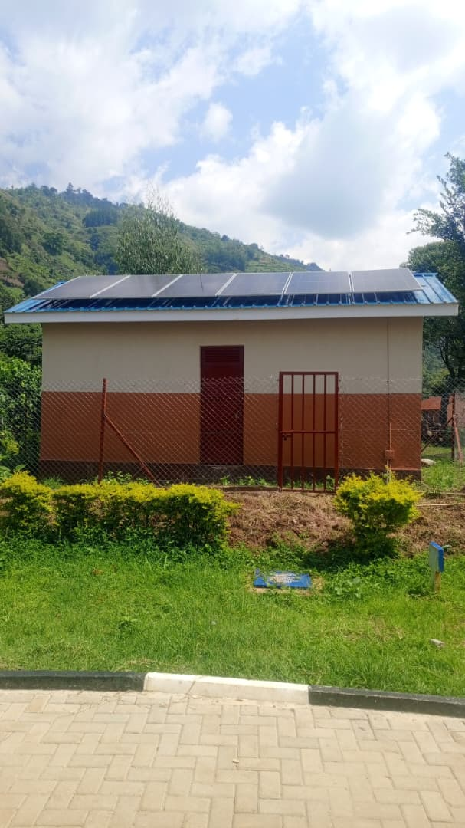

SCHOOL VERIFICATION CHECKLIST

SCHOOL INTERVIEW/DISCUSSION GUIDE

Name of school: NOMBE SEED SECONDARY SCHOOL

1a | Does the Facility have a record of all assets provided under UgIFT.  (Obtain a record and verify if it has the costs and numbers supplied | Yes, but it has no costs.
1b | If Not ask how many were supplied and when. | 426. he is not sure of the exact date.

2 | How does this facility Maintain (repair/service/replace) the assets provided under Ugift

The facility uses the school budget to repair/service/replace all the assets provided under UgIFT.

3 | Does the facility take regular record about functionality/ or breakdown of the assets provided?  Nonfunctional/ working, and reasons for non-functionality. | Yes. The desks were broken (some)

4 | How has the UgIFT support helped in service delivery in the area, any issues, challenges and any recommendations for better program implementation.

- Source of employment opportunities to the community.
- Provides education as a service to the community which has been led to its development.
Recommendations: If possible Ugift should provide more laboratory equipments and the ICT equiments for the students.
Also they are requesting for a boarding section to be constructed because a lot of children come from very far so they reach at school very late.

PROCEED TO VERIFICATION AFTER THIS DISCUSSION

SCHOOL FURNITURE
(School Desks, Office chairs, Laboratory stools, Book shelves)

Name of LG: NTOROKO DISTRICT Name of SCHOOL: NOMBE SEED SECONDARY SCHOOL

Equipment/ Item | Department | Asset Number | Item  Description | Life in Months | Tag Number ( engrave no.) | Date Of Pur | Date Placed In Service | Recoverable cost | Cost | Acc Dep Cost | Net Book Value | Ytd Deprn | Equipment status | Remarks
School desks | Education |  | Wooden and brown in colour |  |  |  |  |  |  |  |  |  | Two desks  were  faulty and  the rest were  in good  condition | They are in use.  100 desks received.
Office chairs | Education |  | Brown in colour. 9 were black with wheels. Some were maroon in colour with spongy seats and metallic seats. |  |  |  |  |  |  |  |  |  | Good condition | All are in use.  They are 161
Labaratory stools | Education |  | Brown in colour with metallic stands. |  |  |  |  |  |  |  |  |  | Good condition | They are all in use.  They are 120.
Bookshelves | Education |  |  |  |  |  |  |  |  |  |  |  |  | Were not constructed.
Tables | Education |  | Wooden and brown in colour |  |  |  |  |  |  |  |  |  | Good condition | They are all in use. They are 26 tables.

ICT ITEMS TO VERIFY
(Desktop Computer, Server Processor, Network Switch 24 Port, Multipurpose Printer, UPS, Projector, Air Conditioners, Server, CCTV Camera)

Name of LG…………………………………………………………………………… Name of SCHOOL………………………….………………………………………

Equipment/ Item | Department | Asset Number | Item  Description | Life in Months | Tag Number ( engrave no.) | Date Of Pur | Date Placed In Service | Recoverable cost | Cost | Acc Dep Cost | Net Book Value | Ytd Deprn | Equipment status | Remarks
ICT ITEMS |  |  |  |  |  |  |  |  |  |  |  |  |  | They never received any ICT items

BUILDINGS TO VERIFY
(Non- Residential and Residential, Kitchen, Toilets/Pit latrine Water tanks, Fences etc.)

Name of LG…………………………………………………………………………… Name of SCHOOL………………………….………………………………………

Equipment/ Item | Department | Asset Number | Item  Description | Life in Months | Tag Number ( engrave no.) | Date Of Pur | Date Placed In Service | Recoverable cost | Cost | Acc Dep Cost | Net Book Value | Ytd Deprn | Equipment status | Remarks
Non residential | Education |  | Painted cream and white |  |  |  |  |  |  |  |  |  | Good condition | They are in use. They are seven in number.
Residential | Education |  | Painted cream and white |  |  |  |  |  |  |  |  |  | Good condition | They are all in use.  They are 3 in number.
Kitchen | Education |  |  |  |  |  |  |  |  |  |  |  |  | Not built.
Toilets | Education |  |  |  |  |  |  |  |  |  |  |  |  | Not constructed
Pit latrine | Education |  | They are painted cream and white. |  |  |  |  |  |  |  |  |  | Good condition | They are all in use.  They are all in use.  3 are for residential and 3 are not for residential.
Water tanks | Education |  | They are black in colour |  |  |  |  |  |  |  |  |  | One is faulty and two are working. | Two in use. They re three. Not constructed.
Fence |  |  |  |  |  |  |  |  |  |  |  |  |  | Not constructed.

